Important links:

1. Matlab tutorial on deep learning webinar

<https://in.mathworks.com/videos/object-recognition-deep-learning-and-machine-learning-for-computer-vision-121144.html>

2) Tensorflow api for object recognition

<https://www.youtube.com/watch?v=COlbP62-B-U&list=PLQVvvaa0QuDcNK5GeCQnxYnSSaar2tpku>

3) Tips for submitting a winning IICDC proposal Rakesh

<https://www.youtube.com/watch?v=Db__yJDdkUg>

4) Quarter Finals Business Criteria Rakesh

<https://www.youtube.com/watch?v=fRu7XJDbCSk>

5) Beaglebone Black urls: Documentation

<http://beagleboard.org/getting-started>

<https://elinux.org/Beagleboard:BeagleBoneBlack#Hardware_Files>

<http://beagleboard.org/discuss>

**Project Makers:**

<https://www.indiamart.com/company/5205471/buy-b-tech-final-year-projects.html>

<http://www.kitsguru.com/>

<http://optimuslabs.in/10-best-places-to-buy-final-year-engineering-projects/>

<http://www.readymadeproject.com/>

<http://www.makefinalyearproject.com/>

<http://www.mycollegeproject.com/>

Quarter Finals – Interim - Project Report / Technical Paper

**Team ID : 134562**

**Team leader name :**

**Project Title : Difficulty, dementia people face, while they search for misplaced belongings which they use in day-to-day life.**

**1. Project Abstract :**

Dementia is a common ailment, which affects people of all demographic areas. Symptoms of dementia includes memory impairment, which results in gradual decrease of cognitive power and affects person's daily functioning. People who are affected with this disease , forgets the location of objects(viz., keys , specs , cards....) where he had put them after their use as their recalling power is very less . So, we would like to help such kind of people, by making a device which can store the location of objects .When asked for the location of particular objects it informs the location.

TrackAtool is a wearable device which uses a cloud-based deep-learning framework to help human-memory to recall the location of their day-to-day objects. This tracks all objects around, providing a simple-yet-efficient mechanism to solve problem that is so prevalent in dementia people. This mechanism, unlike a tag-based object identification, is not limited to objects that have been specifically tagged. It is placed over the clothing, Captures images as user moves around and processes them to extract the objects within them.

// Need to modify image with current parts

**2. Proposed Solution using Block Diagram :**

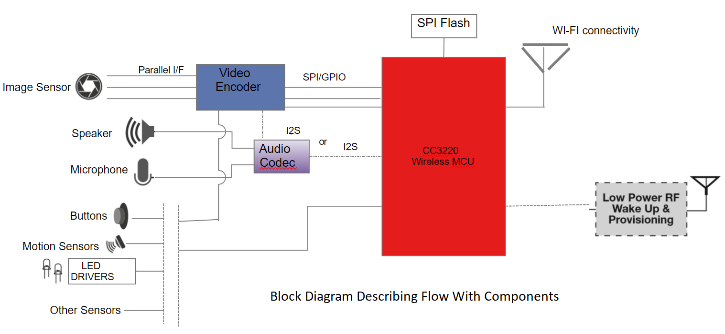

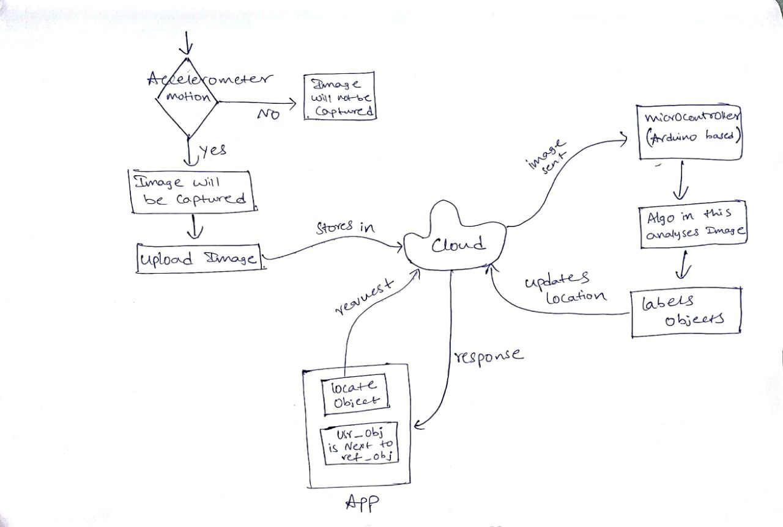

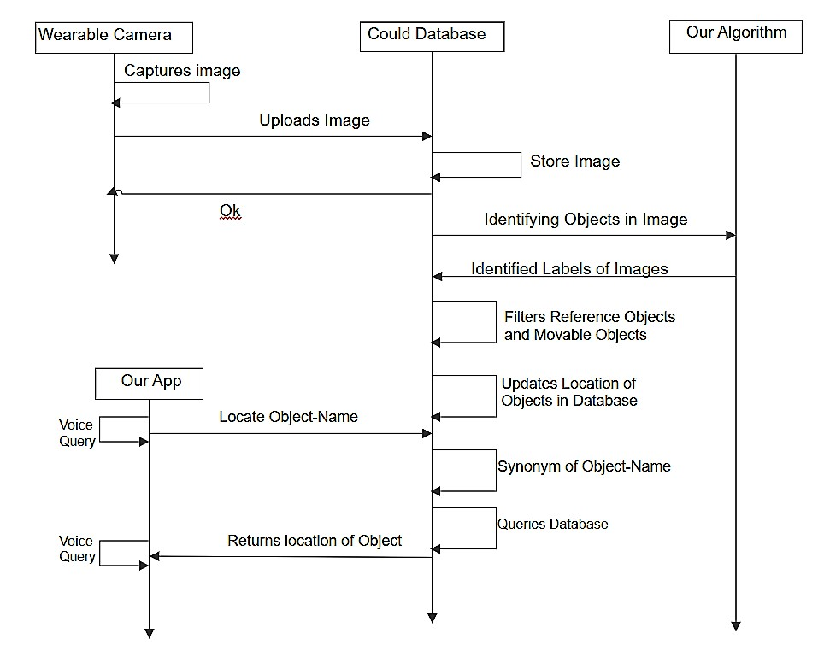

**3. Hardware/Software Implementation of each component : Prasanth**

**Hardware:**

**Prototype with components and working of each component**

1. **Prototype with parts (CAD models )**

**Despite many designs, the below is selected as our Final design of our product by using a scientific tool Pugh’s Method. This shape is designed keeping various points into consideration, as such space optimization, aesthetic sense, ergonomics and users from various demographic regions. This is a simple and visual appealing design we could do our best .**

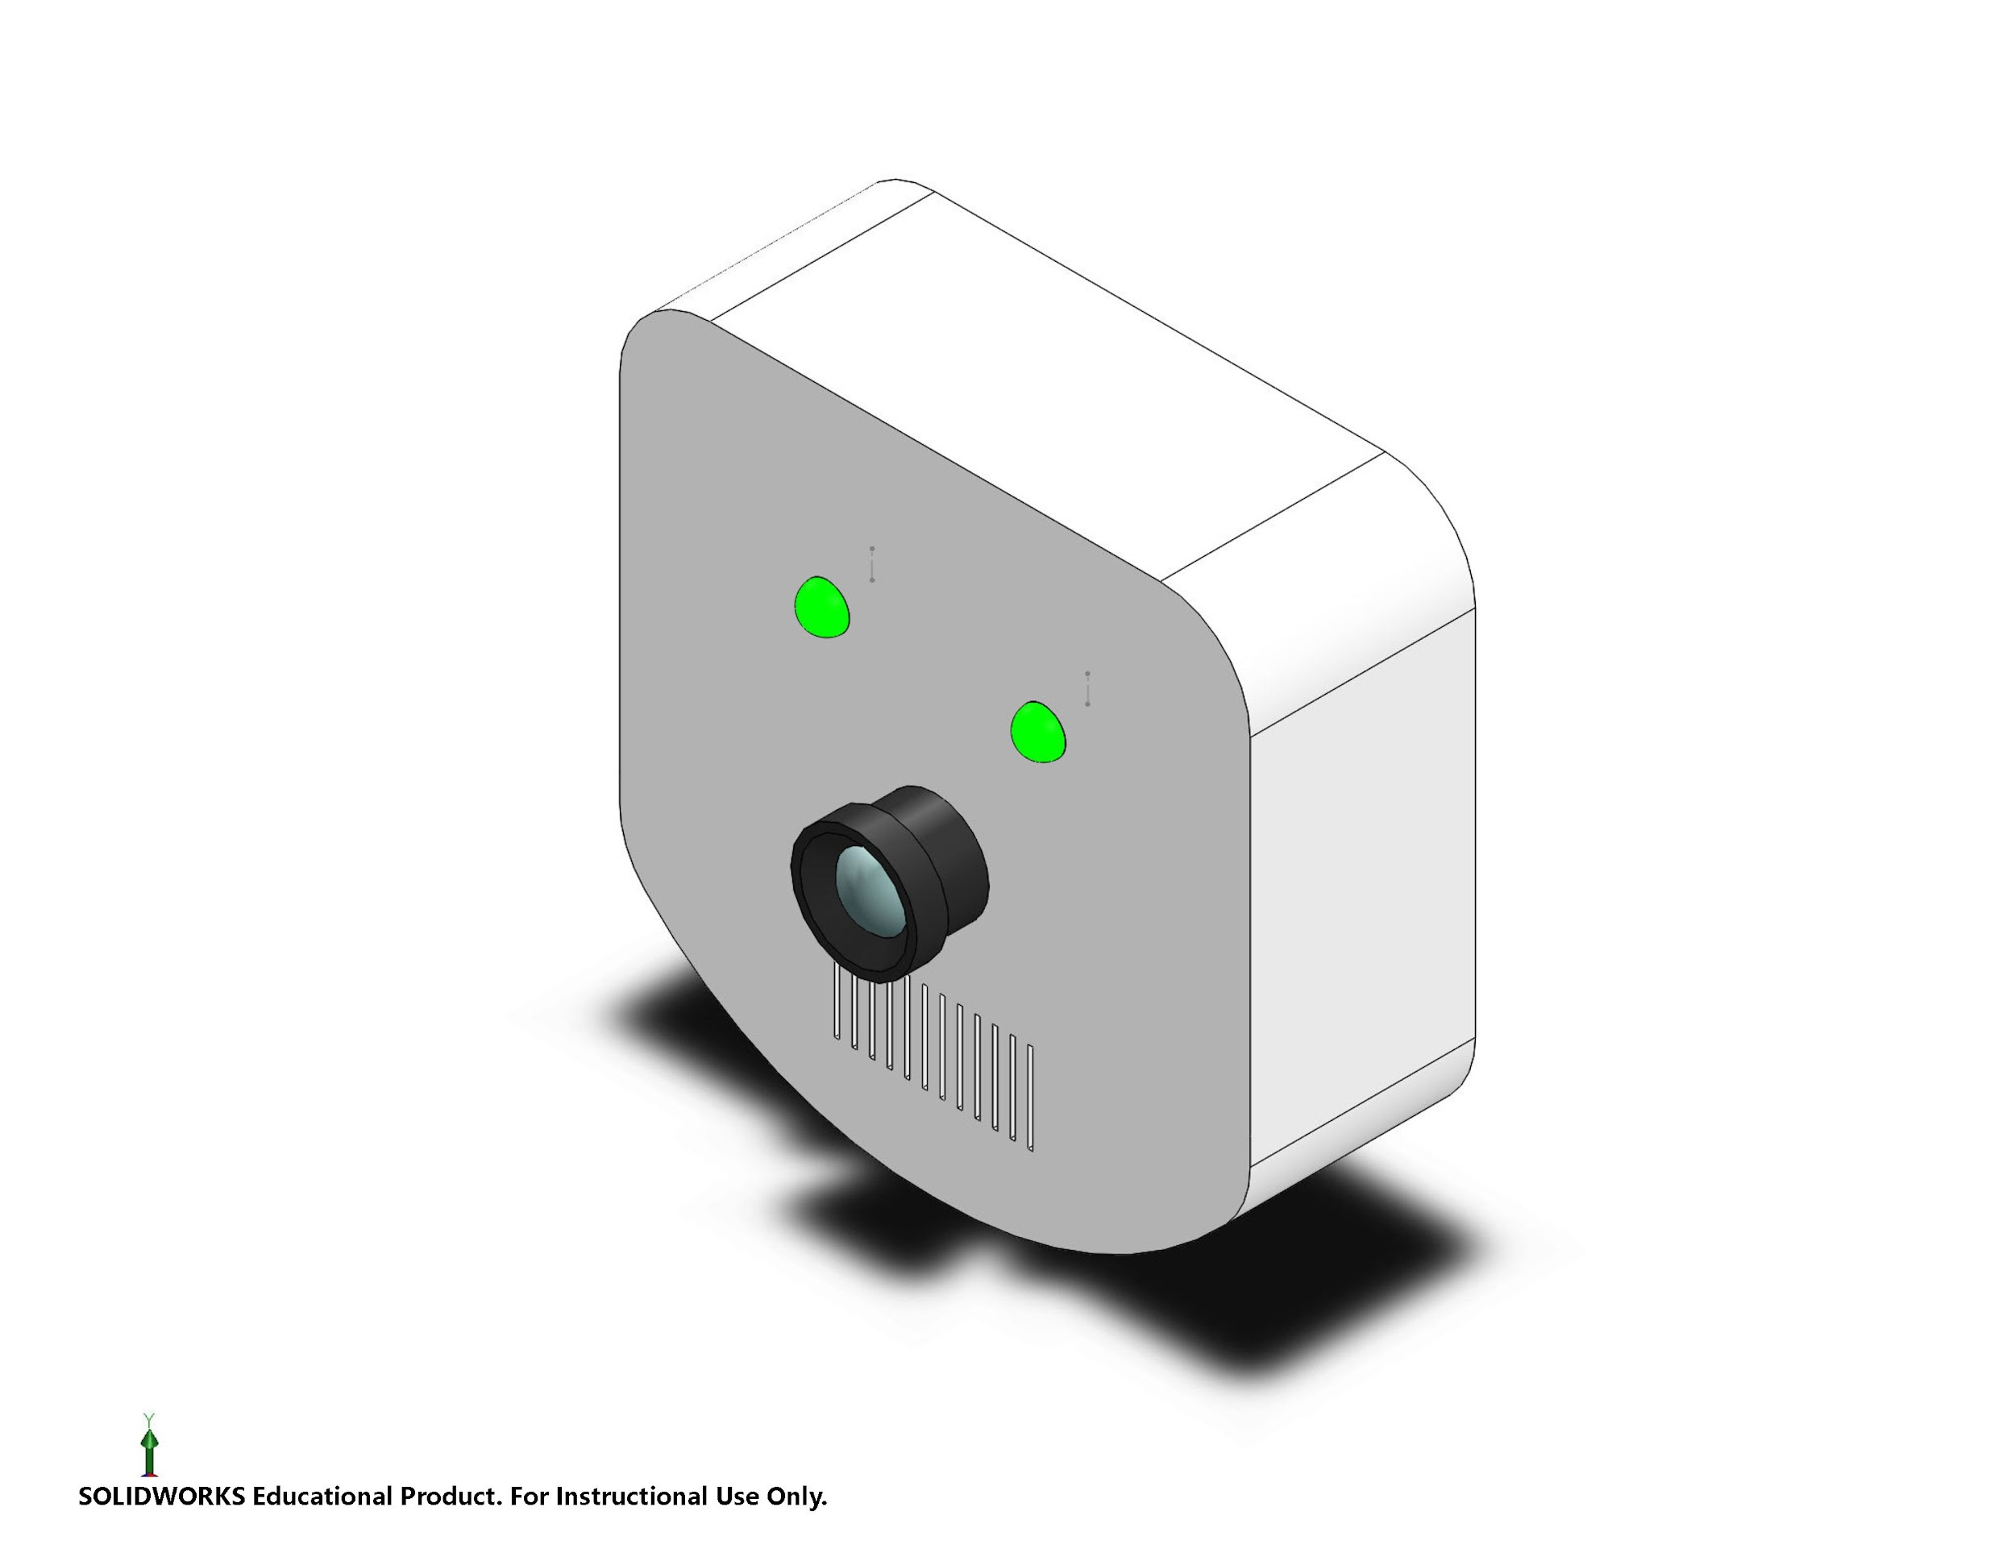

**The interior arrangements of various components can be seen from the below transparent mode of the CAD model**

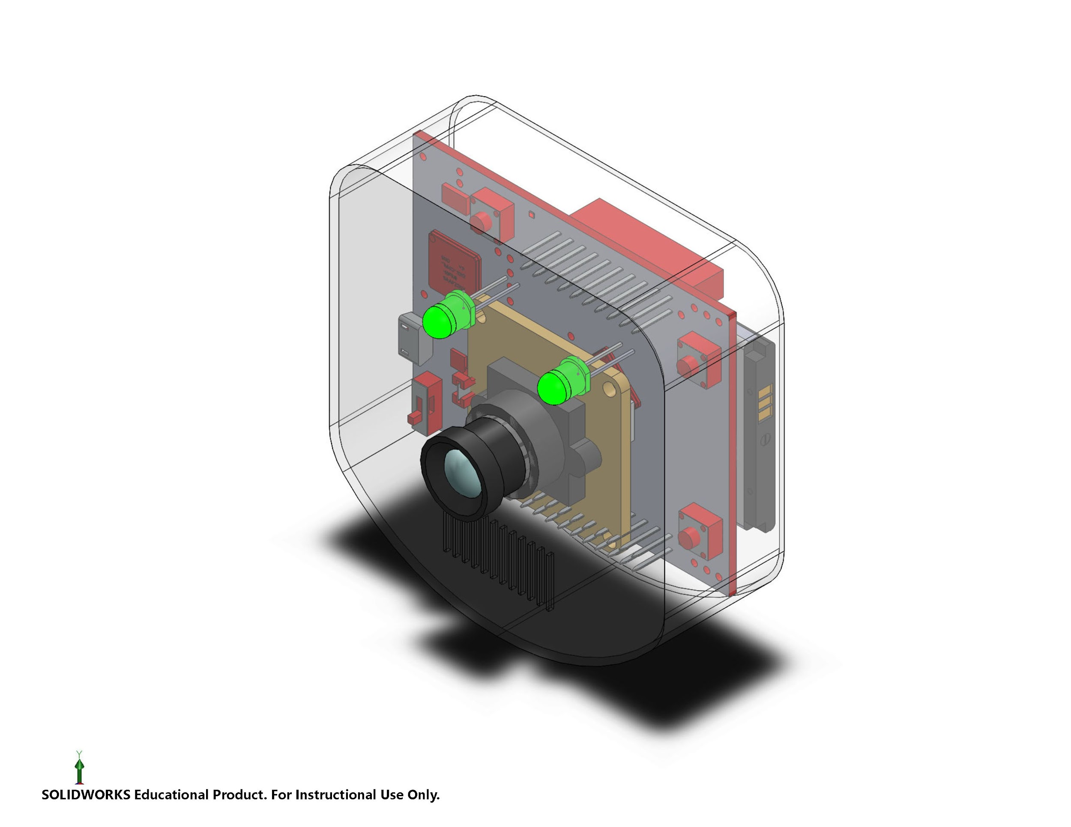

**The exploded view of the CAD model is shown below.**

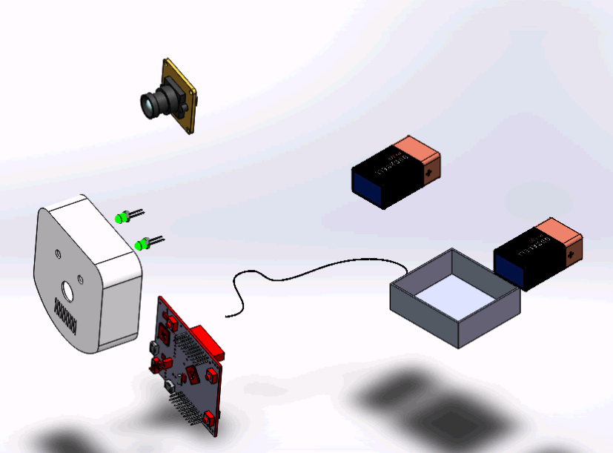

1. **Description of each parts**

**Software:**

Customer after the procuring the device, he/she should have to install the app, which is made for our product. After that customer need to register the device by entering the product’s unique device ID,which will be enclosed in the box at the time of purchase. After registering device, customer should grant the permissions for camera and microphone.Then the app prompts for first reference object and the user must have to click the images of stationary( reference ) object in as many angles as possible. Change the name of object from reference object 1 to corresponding name.Feed the device with as many reference objects as possible and accordingly names should be changed.Then comes the protagonist, the user defined objects, are prompted by the app. Similar to the previous step, user-defined object images should be clicked and provided to the device.Be it a user-defined object or reference object, a clear image is necessary to keep the track of objects. Blurred images are not to be fed to the device. Successful implementation of above steps implies that the user is done with successful installation of the device.

After installation, the user must have to attach the device to his/her shirt with the clip provided.Make sure the device is turned on.Now start moving with the device attached to your shirt.Then the device starts clicking the images which comes under field of view of camera. All the images are sent to the cloud database, and each image is explicitly checked for the user-defined objects( which are readily available in the cloud when clicked previously in the mobile).If no user-defined object is found, then it simply deletes it.If the presence of user-defined objects is found, then it checks for the reference objects in the images.( the reference objects are already present in cloud, which are feeded through app). It then stores the location of user-defined objects with respect to the reference objects.

User or Dementia person, when in need of an object, he/she simply needs to open the app and ask for the object (call out the name of the object, as it is saved in the app). Then the app shows the location of the object with respect to the reference object.

So the user, instead, searching the whole house, now searches near that reference object thereby minimizing his effort.

**4. Expected Outcome :**

This main motive of this device is to make the dementia people life easy and independent by assisting them through forgetfulness of daily belongings.

**Explanation of the benefit**:-

Expected customers of our product can be the caretakers or family members of dementia people .Dementia affected persons are the users. This set also includes people who frequently lose track of their belongings.

Dementia people who claim this device can keep track of their day-to-day objects (by attaching it to their shirt). Speaking about the device, it’s not a huge hardware system. Typically, it’s about the size of mobile phone and nothing much to operate, except for prompting and fetching the location of objects. As this product is a wearable device, Users can get easily acclimated to it. This product makes their life more easy and independent.

In a way, this would be equally beneficial to the caretakers and family members. Besides the busy schedule, always the quality time of the customers (care takers and family members) is being spent in non-productive work of searching things for dementia people. Having a product of ours would make their valuable time more constructive.

**b. work flow with example**

Let us suppose that keys are placed near television. Then the sequence of steps that are going to take place are:

1) First device captures this image.

2) Machine Learning algorithm detects the objects in image.

3) Classifies these objects as keys (moving object) and Television (reference object)

4) Updates location of keys as “Near Television”.

5) When asked “Locate keys” through App

6) It returns “keys are near Television” in voice and text format

**5. Technical Challenges Faced :**

1. First, we thought of storing the captured images in the cloud. But, as it is not possible to have the Ethernet/Wi-Fi facility everywhere, we have changed our idea and we planned to store the images in the sd card which is attached with Beaglebone Black.
2. As we need to use only TI parts for our project, we are need a camera which is compatible with Beaglebone Black. Searching for camera as such, consumed a lot of time and we found that both camera cape and Web camera are compatible with Beaglebone Black. As the cost of camera cape is high and can’t be shipped to India, wee decided to use webcam which can be connected with Beaglebone Black.
3. We need a 3-axis accelerometer for checking the motion (acceleration) in any direction. So, we have ordered Sense Hub along with TIVA launchpad. But as TIVA launchpad is not available, we are provided with Beaglebone Black. Now the sense hub which came along is not compatible with Beaglebone Black.
4. We are in need of power source(like rechargeable battery). Initially we have no good idea on TI parts, so we thought that battery evaluation module can be used as power source. But what we thought is wrong and we are not able to change those parts now as per rules of IICDC.

**6. Non-Technical Challenges Faced :**

1. Prototypes are not made for alternate design due to time bound
2. The product can be built by adding extra features like event remainders, flash in dark and and a high mp camera . But due to financial constraints, nothing of them are incorporated
3. With help of the final prototype, customer working environment is not analysed to develop any changes in the design.
4. Coping up with sudden change of components from TI, which made us to reiterate the process of searching alternate solutions.
5. Changing in the dimensions of the product design as the desired and actual size of the components varied slightly.

**7. Things that add further value to your project :**

Dementia, is a disease which affects all kind of demographic areas and age groups ( ranging from a child to 60 yrs old man). So,More or less, uniqueness of the project is the biggest thing that create value of its own importance. Speaking strictly, the serviceable addressable market (SAM)*,i.e.,forgetfulness of the daily belongings in Dementia people*, is the domain into which no one has looked into and there is no medical treatment till day. Family members and caretakers are the ones, who are sole responsible for searching the things. Saving their productive time and minimizing the effort of searching things adds to the value of our device. Speaking to doctors and their endorsement helped us to make a calculated step of picking up this project. So,tieing up with pharmaceutical industries and creating awareness to the dementia affected families would do much good to our project. The main intent is to make the life of dementia people bit independent and easy which ultimately glorifies the product.

**//Rakesh kinda sentences formations emaina tappu vunte change cheyi**

**//Haa paina okay na?? Haa okay**

**//bagundi**

We can add further value to our product by changing the following factors. They are:

1. Storage
2. Compatibility
3. Efficiency
4. Storage:
   1. We can increase the storage of SD card, so that more Reference locations and more objects can be stored and processed.
5. Compatibility:
   1. Instead of placing the whole parts inside the device. We can separate the camera module and microcontroller. This makes more comfortable for the users.
6. Efficiency:
   1. If we use Deep Learning Framework Instead of Machine Learning Algorithms, we can improve the efficiency of our product. As deep learning framework divide the image into several parts and checks for objects in those parts separately, This Improves both efficiency and time taken for identifying objects.

Beaglebone black:- Beaglebone black is the main component of the product.It is used to connect various other components and the program is fed to the microcontroller which is already inbuilt in this.

Accelerometer:- The same image captured again and again when the person does not move results in the wastage of memory. So it is important to capture the image only when there is motion. So, 3-axis accelerometer detects the motion in any direction and helps in efficient use of memory.

Camera:-

Camera is used for capturing images in the pre-fixed time lapse.

SD card:-All the reference and user-defined objects are stored in the memory card.The captured images from the device are also stored in the SD card

Battery:- As the beaglebone black requires 5V constant supply of input to wake up, this acts as the power source.